STAR BEHAVIOUR POLICY
Approved by: | Ma’am Dolly Goriawala | Date of approval: August 2023
Last reviewed on: | August 2023
Next review due by: | August 2024

Introduction
Within Star International School we believe that every child has the right to feel safe, happy and respected whilst being supported to reach their full potential. Our behaviour policy acknowledges the UN Conventions on the Rights of a child (UNCRC) whilst underpinning the school’s ethos which strives to ensure that all members of the school community and their cultures are equally valued and treated with respect. Our behavior policy aims to uphold the Dubai National agenda UAE vision 2021 core values to create a school united in responsibility, destiny, knowledge and prosperity.
It is the responsibility of each member of our staff to act as a role model for polite, respectful and appropriate conduct. We can in turn encourage our students to show respect for themselves, others, and the environment. At Star we aim to empower students to regulate their own behavior by scaffolding their choices and guiding their actions via a system of positive acknowledgement, opportunities to reflect, and restorative practice.
This policy outlines the key principles, aims, and strategies for promoting the best behaviour at Star International School.
Aims and objectives
- To have a consistent and positive approach to behaviour management, creating an environment that is conducive to learning and success for all within the School Community.
- To have in place established systems that promote and reinforce good behaviour and that deal with incidents of poor behaviour.
- To develop a school environment that is both safe and secure for all students.
- For everyone to take responsibility for their emotions and actions; seeking to develop relationships based upon mutual respect.
- For each pupil to be able to work, play and relax free from abuse, intimidation, harassment, teasing and bullying.
- To manage and support pupils through each transition in their school experience, including: from home to school, onwards to other schools, key stage transfers and throughout the school day.
- To support pupils to build self-regulation through reflection and mediation.
- To make appropriate adjustments for pupils with special educational needs and/or disabilities when implementing this policy.

CONTENTS
Page
3 | Policy Statement
4 | Rules, Rights and Responsibilities:  Student Rights  Student Code of Conduct  Staff Rights  Staff Code of Conduct
5 | Behaviour Management Strategies
6 | Reward and Sanction Guidance Rubric
7 | Breaktime Conduct
8 | Specific incidences of behavior
9, 10 | A collaborative approach | The role of parents, staff, and the principal  Appendix 1 – Secondary Relationship Policy.

Policy Statement
This policy has been written with due reference to the United Nations Convention on the Rights of the Child (UNCRC) which has been signed by the United Arab Emirates and is upheld by KHDA regulations. All safeguarding procedures at Star International School are also in line with KHDA and UAE authority requirements. The safeguarding and protection of children is of paramount importance to everyone in, and associated with our school.
It is the school’s responsibility to provide a safe, secure, and caring environment in which it is our duty of care to protect students from poor behavior (Art. 19: 29: 31 UNCRC). All decisions taken with regard to this policy have been in the best interest of the child (Art. 3 UNCRC). Likewise, the value of student's voice is advocated within our school (Art. 12 UNCRC); the school council and behavior team ensure our students feel free and able to express their views and have any concerns addressed.
We endeavor to make parents and carers aware of the school’s responsibility to maintain behavior, safeguard students, and promote the welfare of all children (Article 5 UNCRC). The publication of policies on the school’s website, parent-student handbooks, and regularly updated communication will ensure this.
Rules, Rights, and Responsibilities
Student rights
- I have the right to be heard
- I have the right to be safe and healthy
- I have the right to learn
- I have the right to have friends
- I have the right to be myself
Student Code of Conduct
- I will comply with all school rules and instructions because I understand that they are they to keep us safe and to help us to learn.
- I will arrive at school on time each day.
- I will wear the correct school uniform neatly and with pride.
- I will treat all adults and my peers with respect at all times and never use verbal or physical aggression.
- I will ensure that I prepare well and am ready to begin each class on time.
- I will move around the school calmly and quietly.
- I will look after the school environment and take care not to cause damage to others’ property.
- I will speak and behave in ways that show my commitment to the principles of Islam and the culture of the UAE.

To promote ownership, the Code of Conduct should be discussed with and signed by students. Adaptions should be made according to age, stage and understanding.

Staff rights
- I have the right to feel supported
- I have the right to feel valued
- I have the right to be safe
- I have the right to be heard
- I have the right to be respected

Staff Code of Conduct
- I will comply with school policies and guidance and ensure consistency in approach.
- I will have a shared responsibility to ensure that the expectations of students are consistently high.
- I will ensure a mutually respectful and courteous attitude towards all members of the school community.
- I will the ensure student's voice is heard, acknowledged, and investigated where there is cause for concern.
- I will support pupils to understand and reflect upon their behaviour whilst helping them to understand the exact reason and nature of any sanction.
- I will use an approach that utilises positive praise and emphasises doing the right thing, rather than drawing attention to those students who are not. Where behaviour is inappropriate, I will focus on the act and not the student.
- I will aim to use a minimum number of sanctions to enforce school expectations.
- I will share responsibility for maintaining standards of behaviour across the whole school, not just within my own class/form. This includes supervision of sensible the movement of students around the school, and intervening where poor behaviour is noticed.
- I will support pupil behaviour with regular explanations, discussions and reminders of school expectations.
- I will maintain a controlled attitude and tone of voice when handling behaviour. Where I feel angry or upset, I will call on other staff members to assist/relieve me.
- I will treat the students as individuals and I acknowledge that approaches may need to be tailored according to need, age, and understanding.
- I will not allow students to leave the classroom without permission, and I will provide the appropriate pass to indicate where permission has been given.
- I will treat my classroom and shared areas with respect.
- I will be courteous to my colleagues by listening to one another respectfully, acknowledging others’ opinions, and being tolerant of the diverse cultures and beliefs of all staff.
- I understand that physical/corporal punishment by any adult is never permissible for any reason, goes against the school and KHDA policy, and would lead to disciplinary action being taken against any person who infringed this rule.

The Code of Conduct should be given to and acknowledged by all members of the teaching staff.

Behaviour Management Strategies
Reward points:
Each key stage will have a system of reward points (Class dojo/ ISAMS) to be awarded where deemed appropriate i.e., Primary/FS (See behavioural stage chart below).
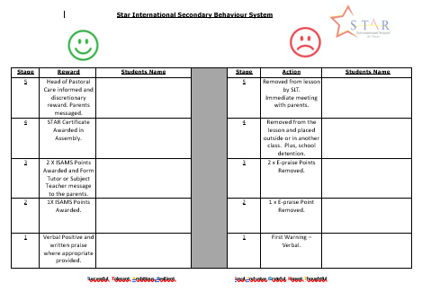
Key Stages 1 & 2 record behavior using Class Dojo and behavior chart system within each classroom 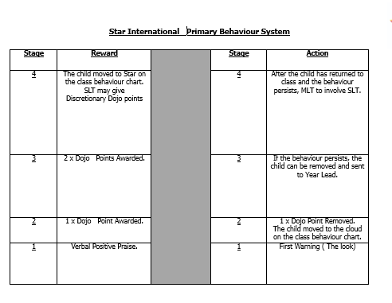

Pastoral awards and certificates:
Dojo points are reset each week. Dojo points can be awarded for a range of positive behaviors determined by the class teacher. Dojo points should be linked to Star values. Students in secondary are to redeem their ISAMS points every Wednesday by selecting an appropriate ISAMS reward and they will receive this on a Friday.
Pupils have the opportunity to earn certificates for positive behaviour (Dojo / ISAMS), and the Star of the Week certificate for work and promoting the Star values. Every teacher nominates each week a Star/s of the Week who will be given a certificate in assembly.

.

Break time Conduct:
The staff on break duty should follow the procedure by reporting incidents to the class teacher (Primary/FS) or Form Tutor (Secondary) if it is felt necessary. Students must ask the teacher on duty, should they need to go to the bathroom, or for any other reason inside the building.
Students should not be allowed to:
- Fight, play fight, or incite fighting
- Chant
- Spoil games
- Go in and out of the building
- Swear
- Provoke or support physical violence
- Climb or sit on walls/railings/fences.
- Disobey or be rude to the supervisors/teachers on duty
- Leave the premises
- Pick up or carry smaller children
- Anything that looks dangerous

Specific Incidences of Behaviour;
BEHAVIOUR PROCEDURE
If a student leaves a classroom or premises as part of an incident - Report the incident IMMEDIATELY to the Principal or Head of School.
- Physical violence with other students - report to the SLT immediately.
- Persistent but mild misbehaviour - Report to class/form teacher.
- Incidents of a very serious nature - Report to SLT; Exclusion may be considered in some instances but can only be done by the Principal.
- Rude or cheeky behaviour (this includes facial expression and body language) - Report the incident to Behaviour team/ phase leaders.
- Bullying: To be carefully investigated and to be taken seriously at all times. Depending on the nature of the bullying, a suitable sanction will be set. Report to SLT.
- Bad or foul language and sexist behaviour should be reported straight away to SLT.
- Racist incidents - Report to the School Counsellor who will take responsibility for dealing with the situation in conjunction with the SLT. Racist incidents are to be logged according to the school’s policy.
For any of these incidents’ parents will be informed by SLT and follow up action to be taken.

Mobile phones - Primary:
Students should not bring a mobile phone to school. The following rules apply:
- Phones must not be used for any purpose during the school day.
- Any member of staff may confiscate a mobile phone that is being used. Confiscated mobiles will be returned directly to parents.
- SIS Al Twar is not responsible for any loss or damage to mobile phones that are brought into school.
- SIS Al Twar and its staff reserve the right to take legal action against students who use their phones illegally, for example by taking photographs or making recordings of others without their consent.

Mobile phones – Secondary:
Students are permitted to bring their mobile phones. During the school day, all phones MUST remain switched off in the student’s bag.

A collaborative approach |The role of parents, staff and the principal:

The Role of Parents:
We are very conscious of the importance of having strong links with parents and good communication between home and school. We work collaboratively with parents, so students receive consistent messages about behaviour. If the school has to use reasonable sanctions with a student, we ask that parents support the actions of the school. If parents have any concerns about the way that their child has been treated, they should initially contact the class teacher. Should the issue still not be resolved then the SLT and lastly the Principal should then be contacted.
In all phases, parents should be invited to connect to the Class Dojo/ ISAMS system using their child’s individual code. From here they are able to see a breakdown of their child’s behavior within school.
The Role of the Class Teacher/Form:
Good classroom management is a key to good behaviour linked to the provision of a high-quality curriculum delivered through interesting and challenging activities that influence positively student behaviour. Teachers at Star International School will be positive, enthusiastic, and have high expectations of both learning and behaviour. They will foster a sense of self-esteem in all students, linked with an understanding of the needs of others.
They will encourage a calm and responsive atmosphere. Teachers will respond to parental concerns in a timely, respectful, sympathetic, and professional manner involving senior staff as appropriate. Teachers must expect that issues will be dealt with in an atmosphere of trust and mutual respect.
It is the responsibility of all staff to ensure that the students in their class and across the school develop self-discipline and behave in a responsible manner.
All staff should follow the correct procedure as per the flow chart below.
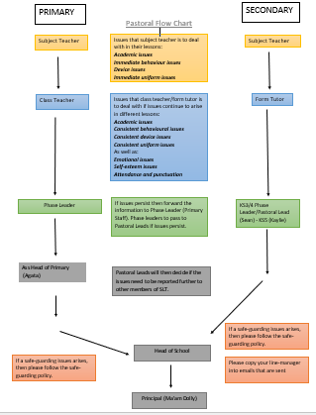
Role of the Principalship:
It is the responsibility of the Principalship linked to the school and KHDA policy, to ensure that the school behaviour for learning policy is implemented consistently throughout the school. It is also the responsibility of the Principal to ensure the health, safety, and welfare of all children (and adults) in the school. The Principal supports the staff in implementing the policy, by setting the standards of behaviour and by supporting staff in the implementation of the policy.
Linked Policies:
- Anti-bullying  - Attendance and Punctuality  - Child Protection  - Equal Opportunities  - Exclusions  - E-safety  - Health and Safety (H&S) | - Healthy Eating and Drinking  - Racial Harassment  - Safeguarding  - School Trips  - Special Educational Needs (SEN)  - Uniform Policy  - Use of Restraint (Positive Handling)

Evaluation and Review:
The effectiveness of the Behaviour policy provided by the school will be undertaken annually and reported to parents.
A review of the Behaviour policy document will be undertaken in August 2023 and annually thereafter.

Appendix One:

Star Al Twar Relationship Policy

Approved by: | Ma’am Dolly Goriawala | Date of approval: Oct 2023
Last reviewed on: | October 2023
Next review due by: | August 2024

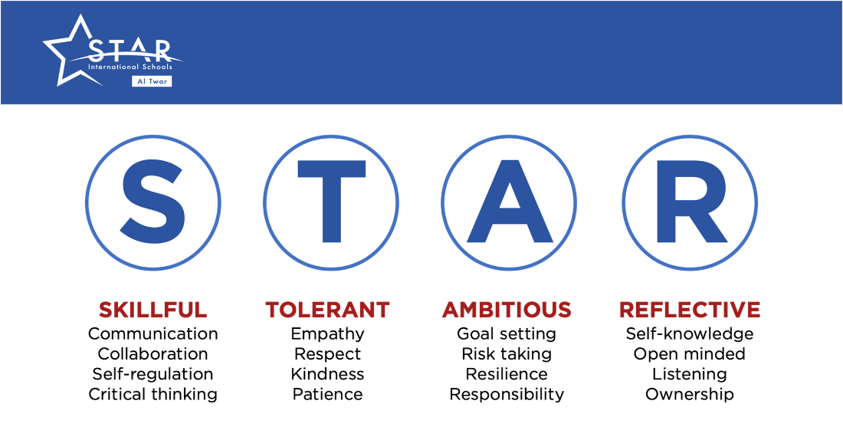

Introduction:

Star International School Al Twar has at its heart a positive regard for all children and a firm commitment to putting the needs of our learners first. We have the highest expectations of all students, and this ensures students are supported to meet these standards and expectations. We never apologise for having high standards in all that we do, and this includes student behaviour.
The aim of this policy is to outline our expectations of staff, students and all stakeholders so that we can best provide a thriving learning environment for all.
Our aims:
- To support our students and staff to consider how their actions contribute to their overall success.
- To build confidence in our learners so they can strive beyond their potential and exceed their own expectations.
- To support our students and staff to make the right choices by carefully employing our ‘Relationship Policy’.
- To become skilful in coaching and reflective conversations to resolve the root cause of issues, leading to the students and staff affecting change.
- To celebrate the successes of our students and staff. Learning is hard work and progress should be acknowledged and celebrated.
- To enable our learners to have a clear vision of what they are capable of achieving by having high expectations of them and creating rich experiences for them.

Staff Specifics
At Star Al Twar we believe positive relationships are key to student success. We have outlined the expectations we have of teaching staff and the role they must play in building effective relationships.
Classroom:
- Ensure students are greeted at the door. Role model positive behaviour.
- Check for uniform, hair, jewellery, and headphones and ensure students are presentable before entering the classroom, calm and orderly when they enter the classroom. Use positive behaviour techniques.
- Ensure a ‘do now’ activity is already on the board for students to enter and get on with.
- Plan and deliver lessons that meet the needs of all learners.
- Whilst teaching, circulate the room and not sit at the desk.
- No phone use or headphones within a lesson and on duty.
- Ensure students finish the lesson 2 minutes early to tidy the classroom/desk, tuck chairs in, wait behind chairs, and wait to be dismissed - check room is tidy and clean.
- All displays to be kept tidy- role model high standards.
- Monitor behaviour in the corridors at the start and end of your lessons.
- Follow the Relationship Policy and record any incident according to it.
Duty:
- No mobile phone use on duty unless to relay an emergency.
- Be proactive and vigilant whilst on duty actively ask students to tidy up and put their rubbish in the bin If near another member of staff, spread out to observe the students.
- Utilise duty to speak with the students and get to know more about them.
- Remain at the duty point until all students have left the area.

Student Specifics
At Star Al Twar we ask that our students live our values, that they are kind to each other, and they try their best. We ask that our students:
- Arrive in school and at lessons punctually and be prepared to learn.
- Wear the school uniform correctly. Noticeable make-up is not allowed. Any make-up must be discreet. The decision as to what qualifies as discreet rests with the Principal and SLT. Jewellery, other than a watch, is not allowed. Smartwatches are not allowed.
- Are polite, courteous, and respectful to everyone on the school campus and comply with reasonable requests or instructions made by staff on the first time of asking.
- To have regard for their own safety and that of others.
- Students are expected to remain on-site throughout the academic day and leave promptly at the end of the day unless engaged in enrichment activities.

Corridor and classroom etiquette:

- Walk quietly in the corridor to be mindful of other lessons taking place – you must have your out of lesson pass with you during lesson time.
- Line up, in single file quietly, outside a class until the teacher greets you and lets you into their classroom - greet them back!
- Tuck your chairs in and tidy the classroom before you leave. Wait to be dismissed by the teacher.
- Be prepared for all lessons with relevant equipment - black/blue pen, ruler, pencil, rubber, purple pen, calculator, maths, PE equipment and a fully charged laptop.

Canteen, student reception and outside benches:

- Make sure you put your rubbish and food waste in the bins provided.
- Line up in a single file to order and collect your food.
- Use please and thank you and treat canteen staff with the same respect as a teacher.
- The canteen is only accessible during break and lunch times.
- When you have food in the canteen, you should be seated at a dining table. Put chairs back if you have added additional chairs to a table.
- Ensure you put your rubbish in the bins and tidy the space you were seated at, at the end of break and lunch.

Technology:

- Zero mobile phones- these will be confiscated until the end of the day if seen.
- Appropriate use of devices/technology.
- No headphones to be used around school.

Parent Specifics

Communication:

- Please directly contact your child's form tutor for any social, emotional or wider (non-subject specific) school concerns.
- Please contact your child's subject teacher directly for any subject-related query in the first instance.

The escalation process for any communication for social and emotional concerns is as follows:
Stage 1: Form Tutor
Stage 2: Head of Pastoral (Mr Sean)
Stage 3: Head of Secondary
Stage 4: Principal

The escalation process for any communication related to academic concerns is as follows
Stage 1: Subject teacher
Stage 2: Head of Department
Stage 3: Head of Teaching and Learning (Mr David)
Stage 4: Head of Secondary
Stage 5: Principal

Attendance and Punctuality:

- Ensure your children are in school on time.
- Ensure your children have the correct full school uniform.
- Please address all staff calmly and with mutual respect.
- If your child is ill on the day, please ensure you email the secondary receptionist and your child's form tutor in the morning.
- Please try to avoid appointments during the school day as this can impact learning time for your child.

Research and Revision:

- Please encourage your child to complete their home learning and practice tasks so they can come to their lessons fully prepared.
- Please have conversations regarding global current affairs with your child. This will help to supplement what we discuss in school and support their growth as global citizens.
- If you want to push your child in a particular subject area, please make use of the Curiosity and Extension folders in your child’s subject Teams.

Consequences of Behaviour

We understand that students sometimes make mistakes and get things wrong, and our Relationship Policy and consequence ladder is designed to reflect this. It is linked directly to our Star Values which enables us to ask students to self-reflect and self-regulate. At all stages of the consequence ladder a restorative approach to student behaviour will be adopted by staff.

The behaviours described below are a guide and staff and the leadership are expected to use their professional judgement when applying the policy.

Reminder Remind the pupil of the expectations linked to STAR Values of being Skillful, Tolerant, Ambitious, and Reflective.
C1 | Respect: e.g., littering with absent-mindedness, eating in an undesignated area, disrupting learning through low-level behaviour, misuse of the device, and lack of effort.  Responsibility: e.g., unauthorised lateness to lessons, failing to bring the correct kit, books or equipment, uniform issues, chewing gum, headphones used without permission. | Reflective conversation/warning to the student.  On the second offence, log C1 on iSAMS.
C2 | Respect: e.g., continued C1 behaviour after warning and log, 3 or more C1 logs in a week, use of inappropriate language (not directed at anybody), repeated disruption of learning, unkind behaviour towards another person, deliberately ignoring staff instructions.  Responsibility: e.g., repeated unauthorised lateness to lessons, repeatedly failing to hand in work, repeated deliberate infringement of uniform. | Reflective conversation with the student.  Log on to iSAMS.  20-minute centralised reflection on Monday lunchtime.  Email home from Head of Pastoral.
C3 | Respect: e.g., more than 5 C1/C2 logs in a week, continuous pattern of C1/C2 behaviour, on-site truancy, damage to school property, use of unacceptable and offensive language (directed at somebody), bringing the Star Secondary School name into disrepute, physical/verbal aggression towards another person, disrespecting somebody else’s culture, religion or faith, social media abuse, academic dishonesty, play-fighting, witnessing and not reporting serious or critical behaviour. | Refer to SLT  SLT to log on iSAMS  Possible sanctions:  - Loss of lunch/break times  - Community Service  - Behaviour Report  - Internal isolation  Meeting with parents.
C4 | Respect: e.g. continuous pattern of C1/C2 behaviour, with no improvement after C3 Sanction, off-site truancy, blatant vandalism, possession of sexually explicit materials, breaking the law by filming or photographing a member of the school community, involvement in substance abuse, including smoking, alcohol or narcotics, serious or repeated bullying, making racist/ cruel/personal/ homophobic comments, possession of weapons/dangerous items, physical assault, purposeful/deliberate humiliation of a member of our community. | Refer to SLT  SLT to log on iSAMS  Possible sanctions:  - Community Service  - Behaviour Report  - Internal isolation  - Formal internal suspension  - Formal external suspension  - Referral to KHDA  Meeting with parents.
C5 | Behaviour Needing Referring to the Authorities Involvement in criminal or illegal activity may lead to being referred to the authorities. | Refer to SLT  SLT refer to KHDA  SLT to log on iSAMS  Possible sanctions:  - Internal isolation  - Formal internal suspension  - Formal external suspension  Meeting with parents.

Rewards for Positive Behaviour

R1 | Verbal Positive Praise.  1 x iSAMS Point Awarded. | Form Tutor Informed.
R2 | 2 x iSAMS Points Awarded. | Class Teacher Sends Positive Communication to the Parents.
R3 | 3 x iSAMS Points Awarded. | Head of the Department Sends Positive Communication to the Parents.
R4 | 4 x iSAMS Points Awarded. | The Head of Pastoral Sends Positive Communication to the Parents.
R5 | 5 x iSAMS Points Awarded. | Head of Secondary Sends Positive Communication to the Parents.

Rewards:
Celebrating student achievement and success is central to what we do here at Star Al Twar. We have connected our reward system to our values to support the celebration of our students.
Students can be awarded for being Skillful, Tolerant, Ambitious, and Reflective in the form of Isams Points, which are also accumulated to house team points:
Points Achieved | Rewards
50 | - Bronze Certificate,  - Form Tutor Praise Letter to the Parents,  - Lead LST, and/or lead a part of a lesson.
100 | - Silver Certificate,  - Head of Pastoral Letter of Praise to the Parents,  - Listen to music using a laptop at break time,  - Receive a hot chocolate,  - Lunch with SLT.
150 | - Gold Certificate,  - Head of Secondary Letter of Praise to the Parents,  - Lead a fitness lesson,  - Non-uniform day on a Thursday,  - STAR gift card.
200 | - Principal Commendation,  - Principal’s Formal Letter of Praise to the Parents,  - Invited to an end-of-term awards ceremony and a school trip.
250+ | - Chairman’s Commendation,  - Chairman’s Formal Letter of Praise to the Parents,  - Discretionary award.

- Parents will be invited to the end-of-term awards ceremony.
- The leading house team will receive a discretionary award from the sports and PE department towards the end of every term.
- Students with high levels of VLE engagement and achievement will receive a VLE certificate presented to them during the end-of-term awards ceremony from the principal, and receive ten iSAMs points each.

